Joe Merrill
20 APR 2026
CMSC 451 Homework 6

Vertex order used in Problems 1-3: a, b, c, d, e

1. Warshall's algorithm

Original relation matrix:

[0 1 0 0 0
0 0 0 1 0
0 0 1 1 0
0 0 0 0 1
0 0 1 0 1]
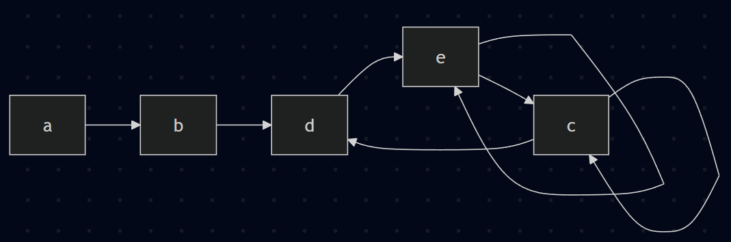
Reflexive closure:

R(0) =
[1 1 0 0 0
0 1 0 1 0
0 0 1 1 0
0 0 0 1 1
0 0 1 0 1]

After outer loop pass k = a:

R(1) =
[1 1 0 0 0
0 1 0 1 0
0 0 1 1 0
0 0 0 1 1
0 0 1 0 1]

After outer loop pass k = b:

R(2) =
[1 1 0 1 0
0 1 0 1 0
0 0 1 1 0
0 0 0 1 1
0 0 1 0 1]

After outer loop pass k = c:

R(3) =
[1 1 0 1 0
0 1 0 1 0
0 0 1 1 0
0 0 0 1 1
0 0 1 1 1]

After outer loop pass k = d:

R(4) =
[1 1 0 1 1
0 1 0 1 1
0 0 1 1 1
0 0 0 1 1
0 0 1 1 1]

After outer loop pass k = e:

R(5) =
[1 1 1 1 1
0 1 1 1 1
0 0 1 1 1
0 0 1 1 1
0 0 1 1 1]

Therefore the reflexive-transitive closure is:

[1 1 1 1 1
0 1 1 1 1
0 0 1 1 1
0 0 1 1 1
0 0 1 1 1]

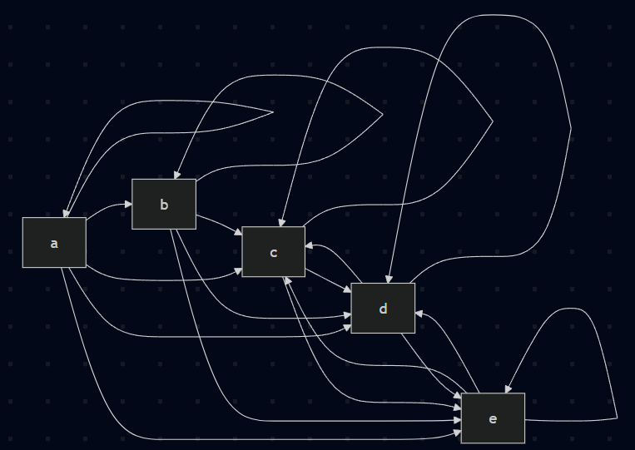

2. Floyd's algorithm on the matrix from Problem 1

Use edge length 1 for each edge, 0 on the diagonal, and inf where no edge exists.

Initial distance matrix:

[0 1 inf inf inf
inf 0 inf 1 inf
inf inf 0 1 inf
inf inf inf 0 1
inf inf 1 inf 0]

Final Floyd result:

[0 1 4 2 3
inf 0 3 1 2
inf inf 0 1 2
inf inf 2 0 1
inf inf 1 2 0]

Interpretation:

- From a, the shortest path reaches every other vertex.
- From b, the reachable vertices are d, e, and c.
- Vertices c, d, and e can all reach one another.

3. Graph, condensation graph, topological order, and closure

Graph corresponding to the matrix in Problem 1:

Adjacency lists:
a: b
b: d
c: c, d
d: e
e: c, e

Compact sketch:
a -> b -> d -> e
^ |
| |
c <- +

Self-loops: c -> c and e -> e

Edges:
a -> b
b -> d
c -> c
c -> d
d -> e
e -> c
e -> e

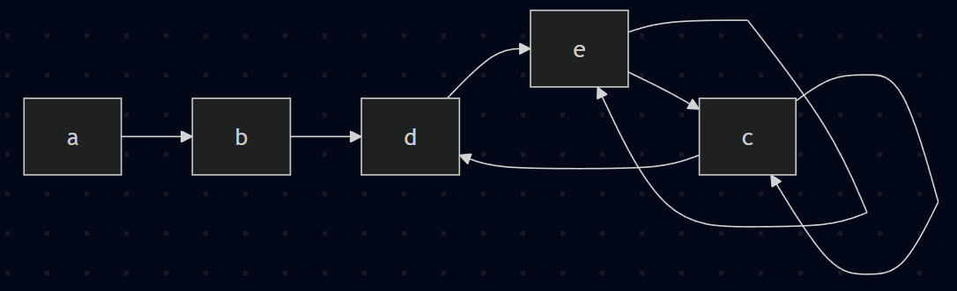

Strongly connected components:

{a}
{b}
{c, d, e}

Condensation graph with renamed vertices:

X = {a}
Y = {b}
Z = {c, d, e}

Edges in the condensation graph:
X -> Y
Y -> Z

Condensation graph sketch:
X -> Y -> Z

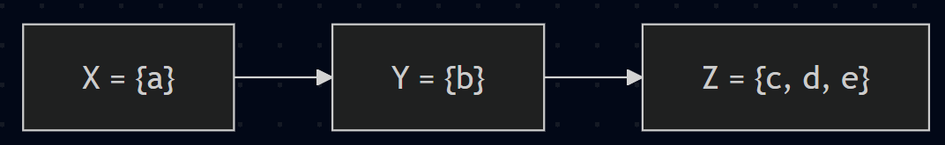
One topological order is:

X, Y, Z

Adjacency matrix in that topological order:

[0 1 0
0 0 1
0 0 0]

Reflexive-transitive closure of that matrix:

[1 1 1
0 1 1
0 0 1]

Characteristic indicating a total order:

Every entry on and above the main diagonal is 1. Therefore for any two vertices in the
chosen topological order, one is always related to the other, so every pair is comparable.
That comparability is the defining characteristic of a total order.

4. Floyd's algorithm on the weighted directed graph

Initial matrix:

D(0) =
[ 0 inf 4 -2
inf 2 3 6
-3 2 0 inf
4 inf 5 0]

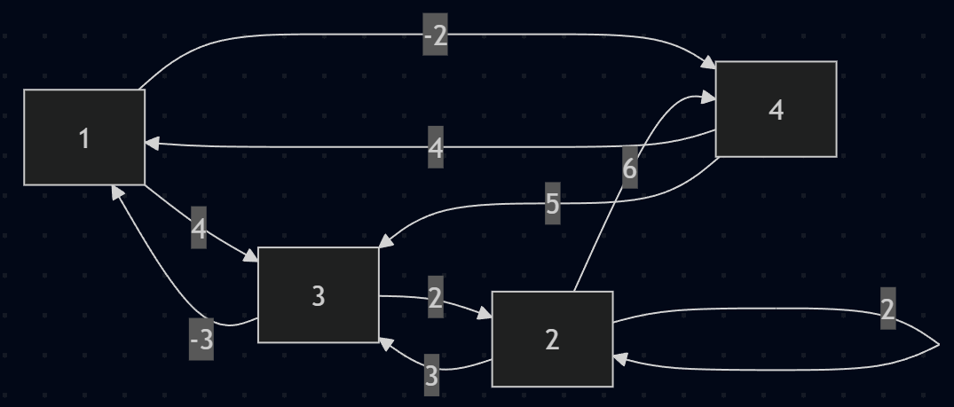
After k = 1:

D(1) =
[ 0 inf 4 -2
inf 2 3 6
-3 2 0 -5
4 inf 5 0]

After k = 2:

D(2) =
[ 0 inf 4 -2
inf 2 3 6
-3 2 0 -5
4 inf 5 0]

After k = 3:

D(3) =
[ 0 6 4 -2
0 2 3 -2
-3 2 0 -5
2 7 5 0]

After k = 4:

D(4) =
[ 0 5 3 -2
0 2 3 -2
-3 2 0 -5
2 7 5 0]

Final distance matrix:

[ 0 5 3 -2
0 2 3 -2
-3 2 0 -5
2 7 5 0]

